Title: Long-term moderate nutrient addition in a mature Andean tropical montane forest changes foliar nutrient concentrations but does not alter isotope derived leaf-level intrinsic water-use efficiency.
Authors:
Andrea Chávez-Pacheco^{a,}, Selene Báez^{b}, Jürgen Homeier, Hans Verbeeck ª, Marijn Bauters^{bc}
*Corresponding author: andrea.chavezpacheco@ugent.be, Coupure Links 653, 9000 Gent, Belgium
Affiliations:
ª Q-ForestLab, Department of Environment, Ghent University, Coupure Links 653, 9000, Ghent, Belgium
^{b} Departamento de Biología, Escuela Politécnica Nacional, Av. Ladrón de Guevara y Andalucía, Quito-Ecuador.
^{c} Isotope Bioscience Laboratory – ISOFYS, Department of Green Chemistry and Technology, 9000, Ghent University, Coupure Links 653, Ghent, Belgium
d Conservation Ecology, University of Marburg, Germany
Keywords:
Nutrient addition experiment, tropical montane forest, isotopes, water use efficiency, elevational gradient, Andes, foliar nitrogen and phosphorus concentrations

Abstract
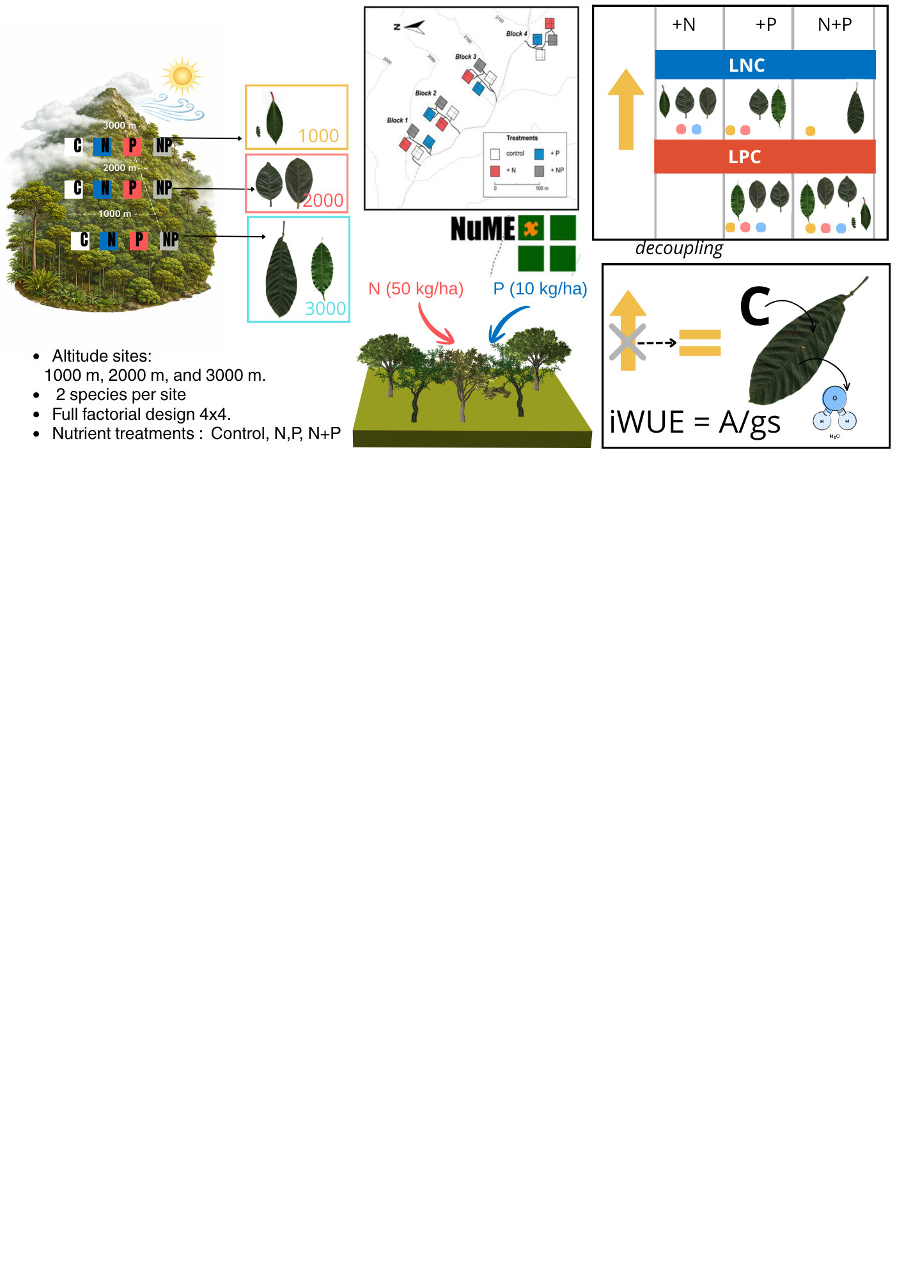

INTRODUCTION

Tropical montane forests (TMFs) cover only 2.5% of the area of tropical forests worldwide (Eller et al., 2020). Despite their limited distribution, they are among the most biodiverse terrestrial ecosystems (XXX) and provide key ecosystem services, including freshwater provisioning to large human populations (Cuesta et al., 2009) and carbon storage (Cuni-Sanchez et al., 2021; Duque et al., 2021). TMFs store substantial amounts of carbon in aboveground biomass and soils, making them important components of regional and global carbon cycles (de la Cruz-Amo et al., 2020). Projected climatic changes, including altered cloud immersion (Crausbay et al., 2015), rising temperatures that increase atmospheric water demand and reduce soil water availability (Brum et al., 2023), together with shifts in nutrient cycling driven by atmospheric nutrient deposition (Velescu et al., 2026a), are modifying the environmental conditions under which TMFs function. However, the ecophysiological responses of TMF trees to these changes remain poorly understood compared to their lowlands counterpart.
Because tropical forests exchange enormous amounts of carbon with the atmosphere each year, small changes in leaf-level physiological processes regulating carbon assimilation and transpiration may scale up to influence ecosystem carbon cycling and climate feedback (Beer et al., 2010; Bonan, 2008; Pan et al., 2011). Intrinsic water-use efficiency (iWUE), the leaf scale relationship between carbon gain and water loss, provides an integrative metric of the balance between photosynthetic carbon assimilation and stomatal regulation, and is therefore a useful metric to assess how trees adjust carbon–water relations under changing environmental conditions (Hatfield & Dold, 2019; Lavergne et al., 2019). Leaf carbon isotopic composition (δ¹³C), the ratio of intercellular to atmospheric CO₂ concentration (Ci/Ca), has been widely used as proxy to infer long-term variation in iWUE and plant carbon–water relations in temperate? And tropical systems (Bauters et al., 2020; Bonal et al., 2000, 2011; Mumbanza et al., 2021). INCLUDE HERE KEY EXAMPLES OF HOW IWUE HAS BEEN USED TO UNDERSTAND PLANT RESPONSES TO GLOBAL ENVIRONMENTAL CHANGE. Consequently, quantifying iWUE in TMFs can help bridge current knowledge gaps on the physiological mechanisms regulating carbon–water interactions and improve predictions of TMF responses to different environmental changes.
An open challenge in understanding biomes’ potential to respond to global environmental change is to evaluate the role of changing nutrient availability. In tropical forests, N and P deposition has increased at a rate of xx% yr-1 and xxx, respectively. In TMF, N and P deposition have changed at a rate of xx…. . Current values are in the order of xxx ha-1 yr-1. Both N and P are key components of the photosynthetic machinery (XXXX). Therefore, increasing nutrient availability could enhance photosynthetic capacity and carbon assimilation (Lankhorst et al., 2025 Stocker et al., 2025). However, the extent to which nutrient availability alters leaf-level carbon–water relations remains unclear. Most evidence linking nutrient availability to iWUE comes from temperate systems or lowland tropical forests. Mainly, studies have been conducted in temperate forest species, where positive responses in leaf iWUE after N addition (Jennings et al., 2016; Perkowski et al., 2025) while other experiments found no responses in iWUE after nutrient addition (Giammarchi et al., 2019; Li et al., 2015; Mo et al., 2021) or negative responses in terms of iWUE due to N pollution (Huang et al., 2016). As a result, the direction and magnitude of nutrient effects on iWUE and related traits remain difficult to predict, particularly in species-rich TMF across elevational and topograhic gradients.
Long-term nutrient manipulation experiments allow investigating how sustained changes in nutrient availability affect crucial aspects of plant physiology. The Nutrient Manipulation Experiment (NUMEX) was established in 2009 in a mature tropical montane forest in southern Ecuador. NUMEX has a full factorial nutrient addition design, at three sites: 1000, 2000 and to 3000 m in elevation. Along this elevation gradient, nitrogen (N) and phosphorus (P) limit tree growth at low and middle elevations, and N, at 3000 m (Camenzind et al., 2019). Previous studies have shown that N+P addition rapidly increase tree growth rates (Homeier et al., 2011), and stimulate growth of tree species with acquisitive resource-use strategies relative to more conservative species (Báez & Homeier, 2018). However, plant responses to nutrient addition remain strongly species dependent, and it is still unclear whether relaxing nutrient limitation translates into shifts in leaf-level carbon–water relations, including intrinsic water-use efficiency (iWUE).
In this study, we use a selection of common tree species in the NUMEX experiment to evaluate effects of long-term nutrient addition on iWUE, leaf N and P concentrations, along an elevational gradient. By focusing on six common tree species and combining foliar nutrient measurements with δ¹³C-derived estimates of intrinsic water-use efficiency (iWUE) and Ci/Ca, we asked: (1) Does long-term moderate nutrient addition alter foliar nutrient concentrations across treatments and elevations? (2) Does nutrient addition affect foliar δ¹³C, Ci/Ca, and iWUE along the elevational gradient? and (3) Are variations in iWUE and Ci/Ca associated with foliar nutrient traits and elevation? We expected nutrient addition to increase foliar nutrient concentrations. However, its consequences for leaf carbon–water relations were less certain. On one hand, eco-evolutionary optimality theory predicts that greater nutrient availability may increase photosynthetic capacity and potentially enhance water-use efficiency by altering the balance between carbon assimilation and stomatal conductance (Lankhorst et al., 2025). On the other hand, if tree species are nutrient limited, alleviating nutrient limitation should stimulate physiological performance (Huang et al., 2016; Lu et al., 2018; Ostertag, 2010; Tanner et al., 1998 ). By addressing these questions, our study evaluates whether long-term nutrient enrichment in mature Andean tropical montane forests modifies leaf nutrient status and the coupling between carbon gain and water use.

MATERIALS AND METHOS

Site description
The present study was conducted at the Nutrient Manipulation Experiment (NUMEX) sites, in the Podocarpus National Park and the San Francisco Reserve (SRF) located in southern Andes of Ecuador. The experiment was established across a 2000 m elevation gradient with research sites at 1000, 2000 and 3000 m, in premontane, lower montane, and upper-montane forests old-growth forests, respectively (Homeier et al., 2013).
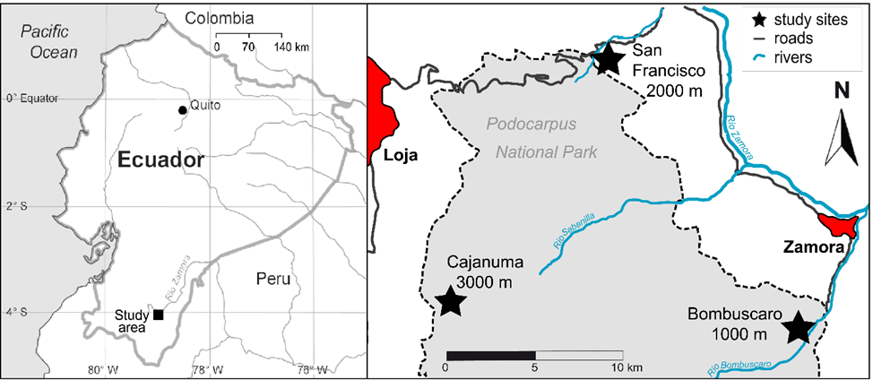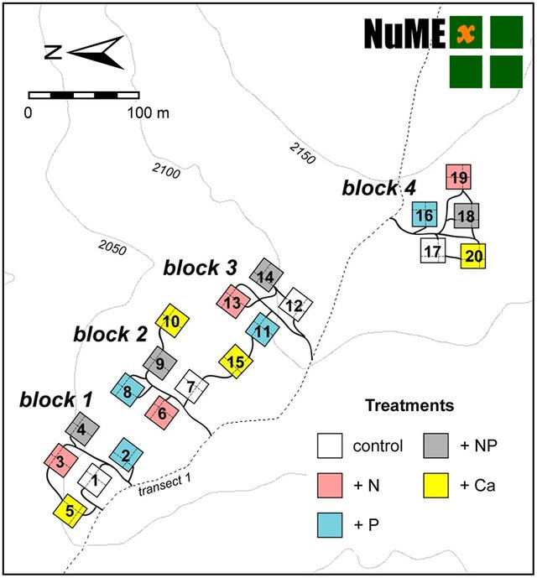
Fig. 1. Experimental Design of the NUMEX Nutrient manipulation experiment in the South of Ecuador (Homeier et al., 2013a)
The environmental conditions shared at the three sites are a tropical humid climate with a wet season from April to July and a less humid period from September to December (Velescu et al., 2026). The study sites are characterized by relatively nutrient-poor soils on granodiorite (1000 m), phyllites and metasandstones (2000 m) or semipelites and black phyllites (3000 m) (Pierick et al., 2024). Soil nitrogen concentrations decrease at the elevation gradient Homeier & Leuschner, 2021a; Wilcke et al., 2009). Mean annual temperature decreases with elevation, and annual precipitation increases with elevation; see Table 1 with site characteristics.
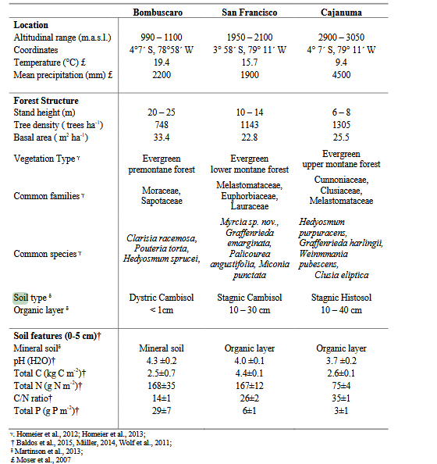
Table 1. Site characteristics of NUMEX data from Cárate-Tandalla et al., (2018)
Experimental design
NUMEX sites were established to explore the effects of increasing nutrient availability on TMF. The NUMEX nutrient manipulation plots were established in closed-canopy stands without signs of recent disturbance Homeier et al., 2013a). The experiment has a full-factorial design with four blocks per site. Each block includes four 20 x 20 m plots, each plot receives annual ammendments of N, P, N+P, or no nutrient addition (control) Homeier et al., 2013a). Since 2008, N addition experimental plots receive of 50 kg ha⁻¹ as urea ((NH₂)₂CO), and P addition experimental plots, 10 kg ha-1 yr-1 (as monosodium phosphate (NaH₂PO₄)) (Homeier et al., 2013a).
For this study, we collected data on locally abundant tree species at each elevation. None of the selected tree species are shared across elevations. See Table 2 and TableS1. Sampling at 1000 and 3000 m a.s.l. took place in November 2024, while samples at 2000 m a.s.l. were collected in November 2023. All sampled individuals had a diameter at breast height (DBH) > 10 cm, except for Hedyosmum purpurascens, that ranged between 5 and 10 cm DBH. Details on the number of replicates for each plot at the corresponding elevation levels are provided in Table 2.
Elevation | Vegetation type | Familiy | Species | Nutrient addition treatment
 |  |  |  | Control | N | P | N+P
1000 | Evergreen premontane forest | Moraceae | Clarisia racemosa Ruiz & Pav | 3 | 1 | 4 | 4
 |  | Sapotaceae | Pouteria torta (Mart.) Radlk | 11 | 10 | 8 | 7
2000 | Evergreen lower montane forest | Euphorbiaceae | Alchornea lojaensis Secco | 12 | 9 | 15 | 8
 |  | Myrtaceae | Myrcia sp nov | 15 | 10 | 11 | 13
3000 | Evergreen upper montane forest | Chloranthaceae | Hedyosmun purpurascens Todzia | 5 | 6 | 7 | 3
 |  | Cunoniaceae | Weinmania loxensis  Harling | 5 | 5 | 6 | 2
Table 2. Overview of experimental design of this study. Figures under nutrient addition treatments indicate the number of trees sampled.

Leaf morphology
We followed the protocol of Pérez-Harguindeguy et al., (2013) to measure leaf traits. Thus, we collected xx sun-exposed tree leaves to measure the following functional traits: leaf area (LA), leaf thickness, force to punch, and specific leaf area (SLA). For thickness and force to punch, three randomly selected leaves per plant were assessed at two points per leaf, avoiding veins. Plant-level measures were calculated by averaging leaf-scale measures, and then averaging among leaves. For each tree, 15-20 fresh leaves were scanned using a flat bed scanner (EPSON V39 II MODEL J371B). The images were analyzed with ImageJ software for calculation of leaf area. Leaves were dried in a stove 72° hours at 70°C. Specific leaf area (SLA) was estimated as the ratio of leaf a leaf dry weight. Dry samples were milled using a centrifugal mill (ZM 200, Retsch, Haan, Germany; 0.25 mm sieve).

Leaf stoichimetry and isotopic composition
Leaf carbon content (LCC), leaf nitrogen content (LNC), and δ13C (‰ v.s.V-PDB) of the bulk were analyzed using an elemental analyzer (Automated Nitrogen Carbon Analyser; ANCA-SL, SerCon, 158 UK), interfaced with an Isotope Ratios Mass Spectrometer (). We also analyzed nitrogen and phosphorus per foliar area to assess photosynthesis-nutrient relationships (Lloyd et al., 2013). In addition, the leaf phosphorus content (LPC) was analyzed using an Inductively Coupled Plasma Analyzer (Optima 5300DV ICP-OES, Perkin Elmer) after digesting the samples with concentrated HNO3. Stoichiometric ratios C: N, N: P, and C: P were calculated at all mass ratios.

We obtained estimates for foliar α-cellulose following the method described by Andreu-Hayles et al. (2019): 30 mg of pulverized sample was added to each glass filter, and then the chemical extractions for the analysis of carbon ( δ¹³C ) was performed. The samples were bleached with a sodium chlorite concentration of 1.5%, followed by a NaOH 10% wash at 70°, and a NaOH 17% wash to ensure a-cellulose is extracted; 0.4 mg of α-cellulose were weighed into tin capsules to determine the isotopic composition of (C ¹³/¹²C) on an elemental analyzer (EA) coupled with the isotope ratio mass spectrometer described previously.

Calculations and statistical analyses

Data analysis
The classic model of C isotope discrimination during photosynthesis $∆^{13}C$ by Farquhar et al., 1982 was used using the cellulose derived delta13C.
$∆^{13}C_{i}=\frac{δ^{13}C_{air}-δ^{13}C_{i}}{1+δ^{13}C_{i}}$ (1)
If respiration-related fractionation, carbon isotope was estimated as:
$∆^{13}C_{i}=a+\left(b-a\right)\frac{C_{i_{}}}{C_{a}}-\frac{fΓ⋅}{C_{a}}$ (2)
where : a represents fractionation during CO₂ diffusion through the stomata (a = 4.4‰), b corresponds to fractionation associated with carboxylation by Rubisco and PEP carboxylase (b = 27‰). An additional term accounts for fractionation during photorespiration (f = 12‰), where Γ* denotes the CO₂ compensation point in the absence of day respiration (≈ 40 ppmv).
$Ci=\frac{Ca\left(Δ13Ccell-a\right)+fτ^{⋅}}{b-a}$ (3)
Photosynthetic rate (A) and stomatal conductance (gₛ) regulate CO₂ concentration in the stomatal cavity (Cᵢ), while atmospheric CO₂ concentration is represented by Cₐ.
$WUE=\frac{A}{gs}=\frac{C_{a}}{1.6}\left(1-\frac{C_{i}}{C_{a}}\right)$ (4)
We used annual atmospheric CO₂ concentrations of 421.08 ppm for 2023 and 424.61 ppm for 2024, together with mean annual atmospheric δ¹³C values of −8.6475‰ and −8.71916‰, respectively, derived from global observatory records from Scripps CO2 Program (http://scrippsco2.ucsd.edu). Atmospheric sample flask were collected along the elevational gradient to assess potential local variation in delta13C, showing no differences (Figure S1). We therefore, considered globally standardized atmospheric records to provide a more robust and consistent baseline for intrinsic water-use efficiency (iWUE) calculations.
Statistical analyses
To analyze trends between the different species were evaluated using one-way ANOVAs on control individuals. Since species composition differed among elevations and no species occurred across all elevation bands, species identity and elevation cannot be disentangled.
For each species, we evaluated nutrient addition effects on iWUE, leaf nutrient concentrations, and leaf traits were using linear mixed-effects models (LMM) where block was included as a random effect. Estimated marginal means (EMMs) were subsequently calculated from the fitted models to compare treatment responses.
LNC and LPC were log-transformed to improve model fit. For all models, normality and homoskedasticity of the residuals were checked visually to assess model validity. All data and statistical analyses were carried out using RStudio (version 4.5.2 RStudio Team, 2020).
Lastly, scaling relationships between iWUE, N content per area and SLA were assessed using standardized major axis (SMA) regression (Wright et al. 2004; Warton et al. 2006; Mantlana et al. 2008). SMA regression is a regression method preferred used when the true slope of a relationship needs to be analyzed, rather than predicting values for a dependent variable from a predictor variable. It is thus commonly used to establish allometric scaling relationships, especially when the two variables are not measured on comparable scales (Warton et al. 2006). What was the aim of this analysis?

RESULTS
Overview – The foliar nutrients showed a stronger response to nutrient addition, while the physiological parameters examined here, namely intrinsic water use efficiency (iWUE), foliar δ13C, Ci/Ca did not show a consistent response across the species. In general, responses from 2000 m and 3000 m were more similar in magnitude than in those from the lower montane site.
 |  | δ13C (‰ v.s.V-PDB) |  | iWUE  (μmol/mol) |  | LNC (mg/g) |  | LPC (mg/g) |  | N:P
 |  | mean | std | mean | std | mean | std | mean | std | mean | std
Clarisia racemosa | C | -30.63 | 0.42 | 36.98 | 5.19 | 17.39 | 2.56 | 0.79 | 0.05 | 21.87 | 2.18
 | N | -31.8 |  | 22.59 |  | 20.06 |  | 0.96 |  | 20.86
 | NP | -30.88 | 0.36 | 33.97 | 4.43 | 23.65 | 1.5 | 1.15 | 0.14 | 20.83 | 3.48
 | P | -29.84 | 1.24 | 46.63 | 15.2 | 19.62 | 2.69 | 1.17 | 0.17 | 16.87 | 2.64
Pouteria torta | C | -31.55 | 0.76 | 25.62 | 9.34 | 15.29 | 1.26 | 0.65 | 0.12 | 24.45 | 5.16
 | N | -31.27 | 0.87 | 40.17 | 22.44 | 15.69 | 1.16 | 0.64 | 0.2 | 25.95 | 5.44
 | NP | -31.74 | 1.35 | 23.36 | 16.58 | 16.38 | 0.98 | 0.73 | 0.07 | 22.58 | 1.81
 | P | -31.27 | 0.93 | 29.13 | 11.48 | 16.68 | 1.52 | 0.77 | 0.13 | 22.47 | 5.11
Alchornea lojaensis | C | -26.51 | 0.89 | 87.61 | 10.75 | 11.61 | 1.5 | 0.78 | 0.12 | 15.07 | 2.24
 | N | -26.57 | 1.13 | 86.9 | 13.72 | 13.14 | 1.82 | 0.79 | 0.15 | 16.83 | 1.83
 | NP | -26.77 | 1.45 | 84.43 | 17.61 | 12.04 | 1.6 | 1.32 | 0.33 | 9.59 | 2.28
 | P | -27.06 | 1.51 | 81.01 | 18.29 | 11.1 | 1.37 | 1.24 | 0.28 | 9.36 | 2.34
Myrcia sp nov | C | -27.79 | 1.15 | 72.02 | 13.97 | 8.82 | 1.17 | 0.43 | 0.17 | 22.9 | 4.05
 | N | -27.24 | 0.92 | 78.7 | 11.13 | 9.99 | 0.83 | 0.43 | 0.03 | 23.54 | 2.22
 | NP | -27.27 | 1 | 78.33 | 12.19 | 9.79 | 0.81 | 0.88 | 0.36 | 12.42 | 3.68
 | P | -27.34 | 0.66 | 77.63 | 8.05 | 8.19 | 0.95 | 1.7 | 0.66 | 6.34 | 5.05
Hedyosmun purpurascens | C | -26.81 | 1.44 | 83.75 | 17.6 | 14.31 | 1.09 | 0.84 | 0.08 | 17.17 | 1.02
 | N | -26.35 | 2.06 | 89.25 | 25.08 | 17.47 | 3.63 | 0.8 | 0.05 | 21.78 | 4.15
 | NP | -24.85 | 1.27 | 107.56 | 15.36 | 17.08 | 1.68 | 1.07 | 0.08 | 15.94 | 0.42
 | P | -27.29 | 1.59 | 77.86 | 19.36 | 15.65 | 1.54 | 1.42 | 0.44 | 12.15 | 3.82
Weinmania loxensis | C | -27.7 | 0.27 | 72.87 | 3.29 | 10.43 | 1.34 | 0.56 | 0.05 | 18.65 | 1.67
 | N | -28.06 | 0.9 | 68.51 | 10.95 | 11.47 | 1.77 | 0.61 | 0.05 | 18.89 | 1.99
 | N+P | -29.03 | 0.79 | 56.6 | 9.7 | 11.17 | 0.14 | 0.72 | 0.07 | 15.57 | 1.25
 | P | -28.38 | 1.13 | 64.54 | 13.8 | 10.73 | 1.7 | 1.64 | 0.44 | 7.31 | 3.43

Table 3. Summary of leaf nutrient concentrations and physiological traits under nutrient addition treatments, presented as means ± standard deviations (SD).
In the control groups, LNC was higher at 1000 m sites in the species: C. racemosa (mean = 17.29 mg g⁻¹ ) and P. torta (mean= 15.20 mg g⁻¹). The values for LNC for 2000m sites: Myrcia sp. nov. (mean = 8.82 mg g⁻¹) and A. lojaensis (mean = 11.61 mg g⁻¹); and 3000 m sites: H. purpurascens (mean = 14.31 mg g⁻¹), W. loxensis (mean = 10.43 mg g⁻¹) are in similar ranges. LNC was statistically significantly higher in N addition comparted to control in A. lojaensis, M. sp. nov. and H. purpurascens. Interestingly, under P addition, P. torta showed an increase in LNC. Lastly, under N+P addition, all species had significantly higher LNC relative to control plots?, in this case significant responses were obtained for C. racemosa, A. lojaensis, Myrcia sp nov and H. purpurascens.
Higher nitrogen per unit leaf area (N_{area}) was found in the species occurring at 2000 m, Myrcia sp. nov. (mean = 2.43 g m⁻²) and A. lojaensis (mean = 3.27 g m⁻²). Across species, N_{area} generally increased in response to N addition, with the strongest response observed in H. purpurascens. Similar to the pattern found for LNC, P. torta had significantly higher N_{area} relative to the control plots. In contrast, for the other species at 2000 and 3000 m, P addition did not result in higher Narea values compared to controls.
No clear patterns were found with the leaf phosphorus content (LPC). Similar leaf phosphorus concentrations (LPC) were found among control plants at different elevatios, with C. racemosa (mean = 0.79 mg g⁻¹), A. lojaensis (mean = 0.78 mg g⁻¹), and H. purpurascens (mean = 0.84 mg g⁻¹) showing comparable values. In the N addition plots, LPC tended to increase in some species, with a significant response for C. racemosa. In contrast, P addition consistently increased LPC across all species. A similar pattern was observed for phosphorus per unit leaf area (P_{area}), which increased under P addition in every species. Under N+P addition, C. racemosa, Myrcia sp. nov., and H. purpurascens exhibited higher LPC values than those in the control treatment. Myrcia sp. nov. and A. lojaensis showed particularly strong increases in P_{area} whit the combination of nutrients. suggesting enhanced phosphorus accumulation when both nutrients were supplied simultaneously.
In the control plots, N:P ratios were similar among P. torta (24) and C. racemosa (23), both occurring at 1000 m, and Myrcia sp. nov. (21) at 2000 m. In contrast, lower N:P ratios were observed in A. lojaensis (14), H. purpurascens, and W. loxensis (17). Nitrogen addition alone generally increased N:P ratios across species, with the strongest response observed in A. lojaensis. However, as described above, species receiving P addition exhibited higher LPC values, resulting in lower N:P ratios under both the N+P and P addition treatments. The enhanced phosphorus acquisition observed in most species under these treatments led to a relative increase in foliar P concentrations and consequently to reduced N:P ratios.
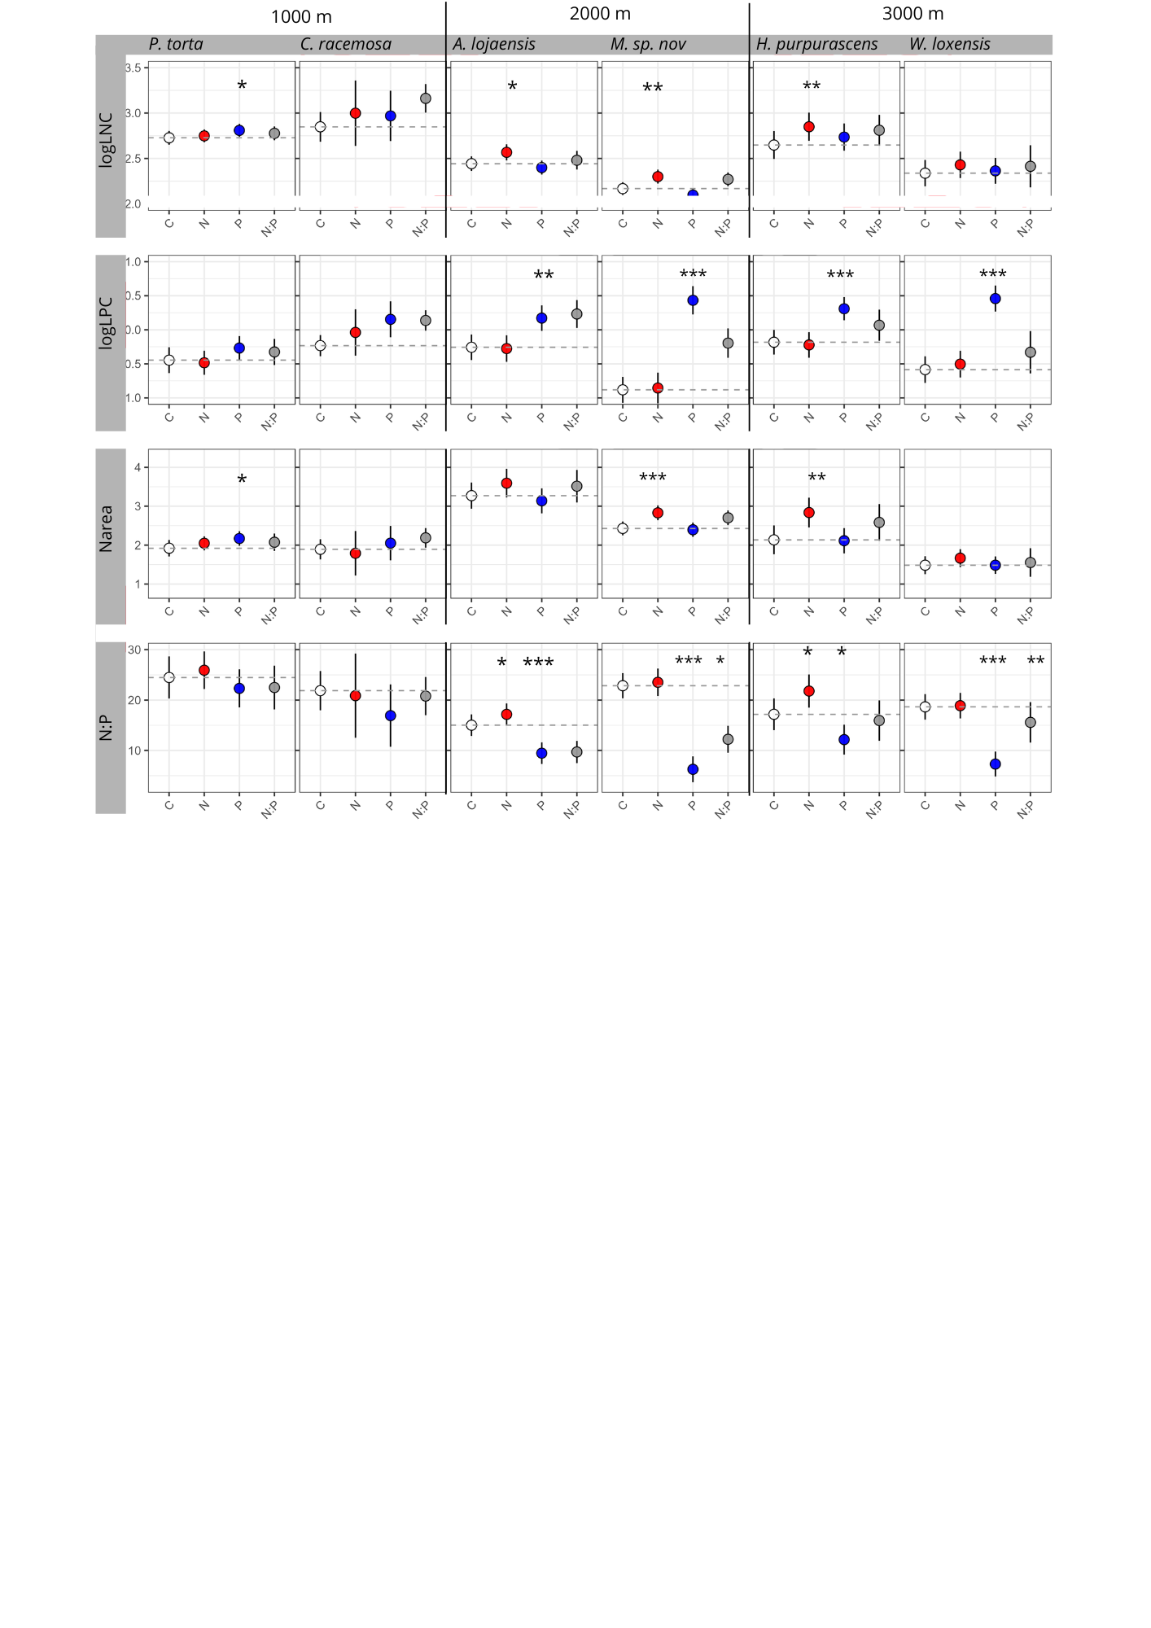
Figure 2. Estimated marginal means (± 95% confidence intervals) for leaf nutrients content log-transformed, Nitrogen per area foliar and ratio N:P across nutrient addition treatments (Control, N, P, and N + P), obtained from linear mixed-effects models with block as a random effect. Dashed lines indicate the estimated mean of the control treatment. Asterisks denote significant treatment effects (P < 0.05). Write here the full latin names of the species.
Intrinsic Water-Use Efficiency (iWUE), δ¹³C, Ci/Ca – Only one of the six studied species (P. torta, at 1000 m elevation) had significantly higher values of iWUE and Ci/Ca in N addition plots, relative to other nutrient addition treatments and control plots Fig xx (Figure S2). Leaf concentrations of δ¹³C were not affected by nutrient manipulations (refxx). However, the result of P. torta is largely driven by a few outlying observations and therefore, we remain cautious about this response. 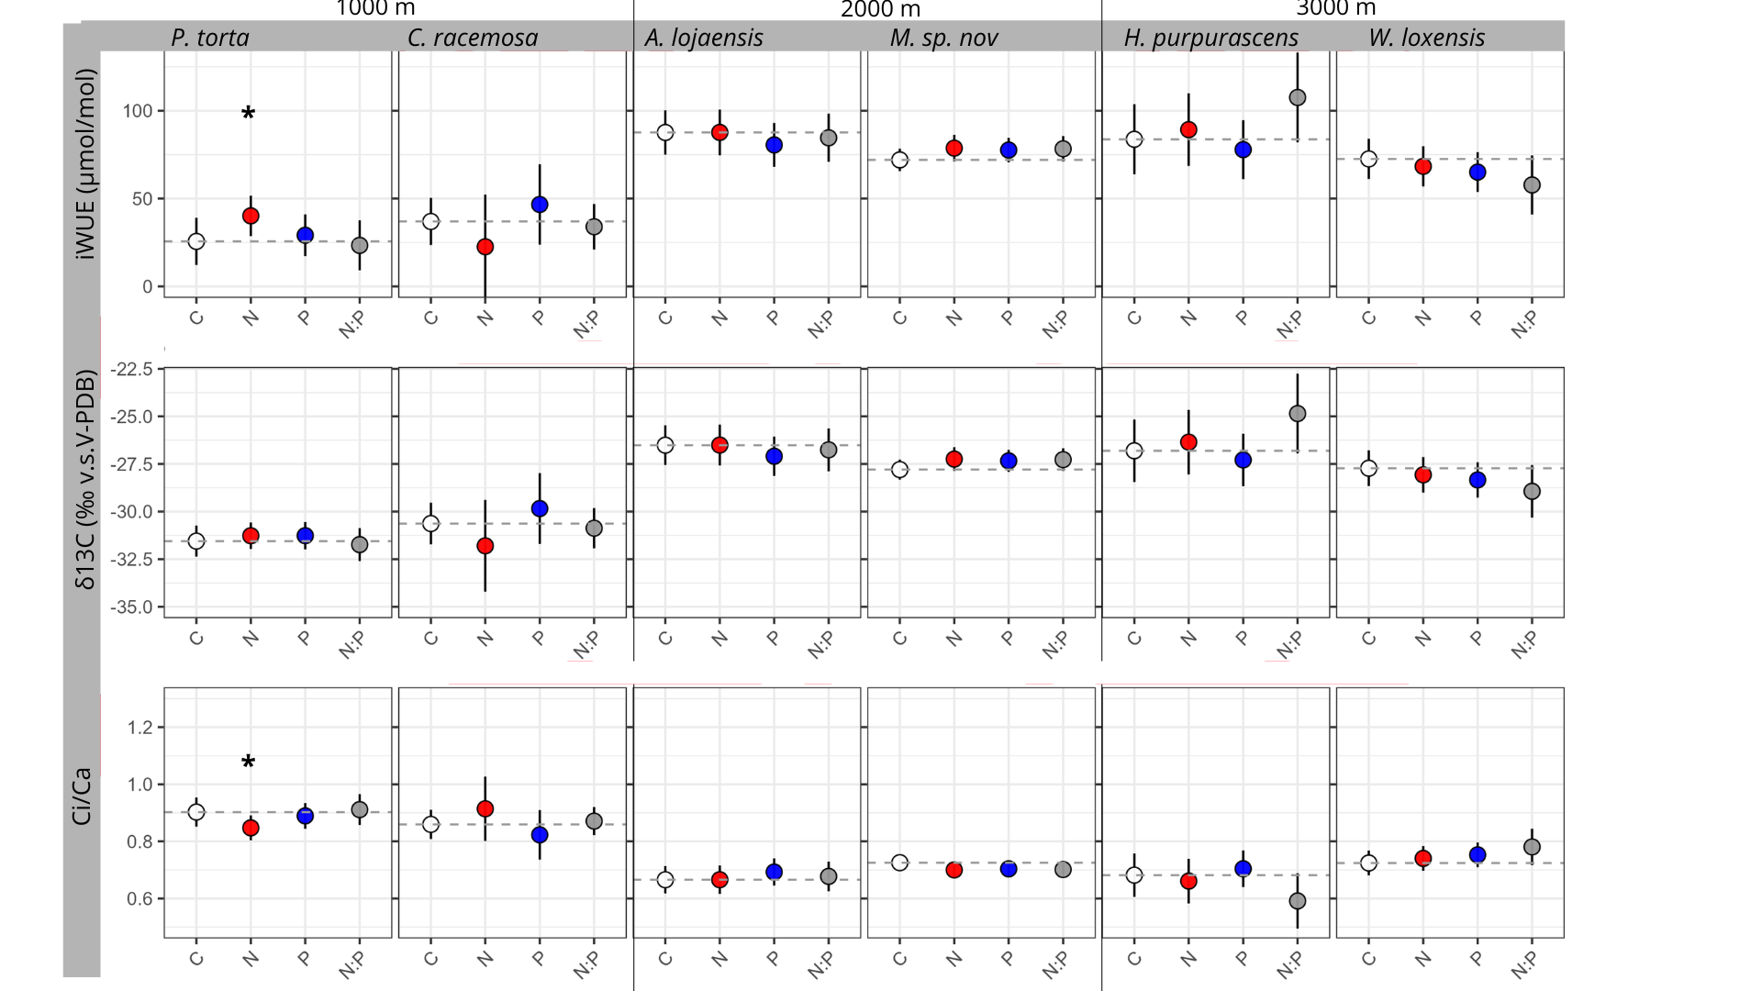
Figure 3. Estimated marginal means (± 95% confidence intervals) for physiological and isotopic traits across nutrient addition treatments (Control, N, P, and N + P), obtained from linear mixed-effects models with block as a random effect. Dashed lines indicate the estimated mean of the control treatment. Asterisks denote significant treatment effects (P < 0.05).
Leaf nutrients and iWUE relationships
Exploratory SMA analyses revealed a consistent negative association between SLA and iWUE across all six species, with slopes ranging from −1.05 to −3.64. Species with lower SLA tended to exhibithigher intrinsic water-use efficiency, suggesting a coordination between conservative leaf construction and water-use strategies. This relationship was particularly strong in Myrcia and Alchornea, which showed the steepest negative slopes (−3.55 and −3.64, respectively) and the highest explanatory power (R² = 0.52 and 0.26) (Figure S3).
In contrast, SMA analyses showed a positive association between Narea and iWUE across all species, with slopes ranging from 27.3 to 64.8. The strongest relationships were observed in Pouteria torta, Hedyosmum purpurascens, and Weinmannia loxensis.

DISCUSSION

General overview
Our results show that, after 18 years of moderate nitrogen and phosphorus addition in the NUMEX experiment, only one species exhibited a significant increase in leaf intrinsic water-use efficiency (iWUE) relative to other treatment? And control plots, despite of having higher foliar nutrient concentrations and changes in foliar morphological traits. This indicates that enhanced nutrient availability and foliar nutrient accumulation were generally insufficient to generate sustained shifts in the balance between carbon assimilation and stomatal regulation.

Leaf nutrient responses -
Primary productivity in TMF is supposed to be limited by (N) or colimited by N and phosphorus availability (Elser 2007, González & Ostertag) and therefore, we expected stronger responses with increasing limitation. In line with expectations, our results indicate that species at 2000 and 3000 m responded strongly to the nitrogen addition with higher LNC, LPC, and N_{reas}. LNC and LPC are key elements analyzed in several articles as a consistent indicator of a response of nutrient availability increases experiments (Báez & Homeier, 2018; Baldos et al., 2015; Dietrich et al., 2016; Firn et al., 2019; Homeier et al., 2012a, 2013b, 2017). Nareas generally increased after N addition, but the only strong response was for Myrcia sp.nov and Hedyosmum purpurascens. In our case, expressing leaf N on an area basis helped reveal that species at 2000 m maintain greater nitrogen investment per unit leaf area, highlighting the importance of structural effects in shaping foliar nutrient patterns. Results are consistent with previous research conducted in the area with seedlings (Cárate-Tandalla et al., 2018) ; and mature trees (Homeier et al., 2012b, 2021). One possible explanation for the similar responses at 2000 m and 3000 m is the shared parent rock material that has led to a similarity in the community and in the leaf properties (Homeier & Leuschner, 2021a). Additionally, the high N/P ratios reported in this article and previously have been suggested that nutrient stoichiometry is largely determined by species-specific nutrient acquisition and allocation strategies rather than by local edaphic conditions (Homeier et al., 2021). Taken together, these results suggest that nutrient addition does influence foliar nutrient in these mature montane forests, but that responses are filtered by species-specific nutrient acquisiton strategies, and shared geological context at the upper elevations.

TMFs response in iWUE is not sensitive to nutrient inputs -
Contrary to our hypothesis, intrinsic water-use efficiency (iWUE), Ci/Ca, and δ¹³C did not show significant changes to N, P, and the combination of both, despite observed increases in leaf nutrient content. This indicates that increased nutrient availability does not alter the balance between carbon gains and water loss in these species. To our knowledge, studies explicitly examining iWUE responses to long-term nutrient addition in mature trees from TMFs remain scarce.
One possible explanation for the lack of response could be that nutrients are being allocated for other purposes besides photosynthesis. According to optimality theory, plants should allocate resources to minimize the costs of acquiring the most limiting resource while maintaining carbon gain. Thus, if nutrient addition relaxes N or P limitation, the balance of constraints may shift toward other limiting resources (ex. water or light). Previous studies (e.g., Dusenge et al. 2015; Ziegler et al. 2020) have shown that, in tropical montane forest species, total nitrogen content—whether expressed on a mass or area basis—is not always a good predictor of photosynthetic capacity. This is largely because nitrogen allocation within leaves varies depending on the species' ecological strategies. Climax species may allocate a greater proportion of nitrogen to structural components, defense, or light-harvesting complexes rather than to carboxylation machinery (e.g., Rubisco). Likewise, P could be located mainly for nucleic acids (Zhang et al., 2018). As a result, increases in LNC or Narea do not necessarily lead to proportional increases in photosynthetic capacity because they are being allocated for different purposes. In our case, the selected species are adapted to nutrient-poor soils and are more conservative in their strategies (see Pierick PCA), which may be associated with inherently conservative water-use strategies. Likewise, ontological effects may play a role; mature trees have shown to maintain stable their water use strategies(Yan et al., 2022a). Lastly, trees at the upper site are exposed to persistent cloudiness and low-light conditions (Wittich et al., 2012) which may promote greater nitrogen allocation to light-harvesting rather than to carboxylation. Therefore, future work could explore whether nutrient responses and allocation patterns diverge among species with contrasting ecological/adquisitive strategies.

In the study sites, there is evidence that added nutrients are allocated into structural and canopy level adjustments for some species. Previous work has shown that nutrient addition promoted greater foliage production in common species such as Alchornea lojaensis (Spannl et al., 2016), increased stand-level leaf area index through greater foliage accumulation and was associated with longer leaf lifespan under higher phosphorus availability (Homeier et al., 2013). Together, these findings suggest that in these montane forests, added nutrients may be preferentially allocated to foliage development and structural maintenance. Here, the lack of responses at leaf-level could be explained because plants prioritize allocating resources to create a great number of coordinated leaves instead of overinvesting resources for photosynthesis in a single leaf (Lankhorst et al., 2025). Likewise, it has been suggested that possibly due to increased self-shading and litter accumulation in more structurally developed stands, stomatal conductance could remain stable even after N addition (Yan et al., 2022b). Testing this hypothesis will require integrating leaf-level physiological measurements with canopy structural traits to determine whether nutrient-induced increases in foliage production compensate for the absence of changes in performance per unit leaf area.

IWUE trends and association with foliar traits-
Although long-term nutrient addition did not modify intraspecific iWUE, clear differences emerged between species across the natural elevational gradient. Common species from mid- and high-elevation site exhibithed the highest iWUE (Fig S2) sharing more similar carbon–water traits than those at 1000 m. The observed differences likely reflect coordinated variation in nutrient availability, leaf functional traits, and community composition along the elevational gradient. Previous work from the same study region reported maximum photosynthetic rates around 2000 m, coinciding with higher foliar nutrient concentrations (Wittich et al., 2012). Likewise, our results showed greater nitrogen investment per unit leaf area (Narea) in the mid-elevation species, which may contribute to the relatively high iWUE observed in these species. In contrast, the species at 1000 m displayed a distinct relationship between leaf nutrient investment and iWUE, indicating a different coordination between nutrient acquisition, leaf structure, and carbon–water exchange.
Together, these findings suggest that natural variation in nutrient availability across the elevational gradient is more strongly associated with leaf carbon–water relations than experimental nutrient enrichment. Rather than responding plastically to increased nutrient supply, the dominant species appear to maintain conservative, species-specific physiological strategies. Because elevation, nutrient availability, and species turnover are inherently confounded in this study, future work including a larger number of species occurring across multiple elevations will be required to disentangle the relative contributions of environmental filtering, nutrient availability, and species identity to patterns of water-use efficiency in TMF.

Implications for the TMF and carbon uptake models.
Despite evidence from the NUMEX experiment that nutrient additions alter foliar nutrient concentrations and several ecosystem processes in Ecuadorian TMF, the absence of a consistent iWUE response in the dominant tree species studied here indicates that carbon–water relations may remain strongly constrained. Such conservative carbon–water strategies may confer physiological stability under changing environmental conditions, allowing dominant species to maintain coordinated carbon assimilation and water use despite increased nutrient availability (Reich, 2014; Smith & Keenan, 2020). Consequently, future changes in carbon sequestration in TMFs may depend more on shifts in forest structure, species composition, and leaf area than on enhanced leaf-level physiological efficiency.
On other hand, these results are relevant for the current frameworks, which may overestimate leaf-level physiological responses if they assume that nutrient alleviation automatically enhances carbon assimilation through changes in stomatal or photosynthetic functioning (Waring et al., 2023). Consequently, we conclude that predicting future dynamics on forests dynamics in response to nutrient-induced changes in TMF species require a better understanding of the allocation of nutrients and responses to other limiting factors.

CONCLUSIONS
The results from the NUMEX experiment are consistent with research done in the area in previous years showing that nutrient additions, particularly phosphorus, significantly increased leaf phosphorus concentration (LPC) across species and elevations, indicating a clear physiological uptake response.
However, these changes in foliar nutrient status did not translate into consistent shifts in intrinsic water-use efficiency (iWUE) and delta13C under nutrient addition, which remained largely unresponsive across elevations. This suggests that nutrient availability was not a primary driver of iWUE in the studied species over the duration of the experiment. Nevertheless, the observed variation in leaf nutrient concentrations and iWUE along the elevational gradient provides insights into how these traits are associated with elevation, even though nutrient addition itself did not directly influence iWUE.
The observed decoupling between foliar nutrient enrichment and iWUE highlights that increased nitrogen availability does not necessarily enhance carbon–water coupling at the leaf level. Or that nitrogen content could be allocated for other purposes beyond photosynthesis (e.g. building more leaves or into light capturing compounds).
These findings emphasize the importance of considering multiple leaf nutrient metrics and environmental gradients to better understand physiological responses under changing nutrient and climatic conditions.

Acknowledgments
Special thanks go to Karina Gonzalez, the field coordinator and local people who helped with the sample collection and scientific follow-up. Additionally, we would like to thank Elise and Katja for their help with the isotopic analyses of the leaf material.

CRediT authorship contribution statement
Andrea Chávez-Pacheco: Writing – original draft, Data analysis, Lab work, Sampling, Investigation, Conceptualization, Data curation Marijn Bauters: Writing – review & editing, Investigation, Conceptualization, Resources, Funding acquisition, Data curation.

Declaration of Competing Interest
The authors declare not to have any known conflict of interest.

Data availability
Data will be made available on request.

Funding sources
This study was made possible by the VLIRUOS-TEAM Project: Restoration and Recovery of Tropical Mountain Forest.

Declaration of generative AI and AI-assisted technologies in the writing process
During the preparation of this work, the first author used ChatGPT in order to improve the grammar and language of the manuscript and kept 95% of the original ideas and text.
References

Suplementary Material

Table S1. Overview of tree characteristics. A principal component analysis (PCA) based on soil C:N and foliar functional traits ((Pierick et al., 2024)) positioned the study species along an acquisitive–conservative resource-use spectrum. From the least to the most conservative, species were ordered as C. racemosa, P. torta, H. purpurascens, A. lojaensis, M. sp. nov., and Weinmannia sp. a Maximum diameter based on stimation from datasets from forest dynamics.
elevation | Vegetation Type | Familiy | specie | Wood density  (g/cm³  ) | Maximum Height (m) | Maximum Diameterª
1000 | Evergreen premontane forest | Moraceae | Clarisia racemosa Ruiz & Pav | 0.59 | 20-40 | 50-120
 |  | Sapotaceae | Pouteria torta (Mart.) Radlk | 0.79 | 6-18 | 100-600
2000 | Evergreen lower montane forest | Euphorbiaceae | Alchornea lojaensis Secco | 0.52 | 9 | 235.56
 |  | Myrtaceae | Myrcia sp nov | 0.72 | 10 | 13
3000 | Evergreen upper montane forest | Chloranthaceae | Hedyosmun purpurascens Todzia | 0.49 | 7 | 226.92
 |  | Cunoniaceae | Weinmania loxensis  Harling | 0.54 | 7 | 139.36

Figure S1. To assess whether leaf δ¹³C varied along the elevational gradient, we fitted a linear mixed-effects model with elevation as a fixed effect and species as a random effect. No significant relationship was found between δ¹³C and elevation (β = −0.0001, SE = 0.0004, z = −0.27, p = 0.79). Consistent with this result, the scatterplot showed substantial variation in δ¹³C values across the elevational gradient without a clear directional trend. These findings suggest that elevation alone did not explain variation in δ¹³C across the sites
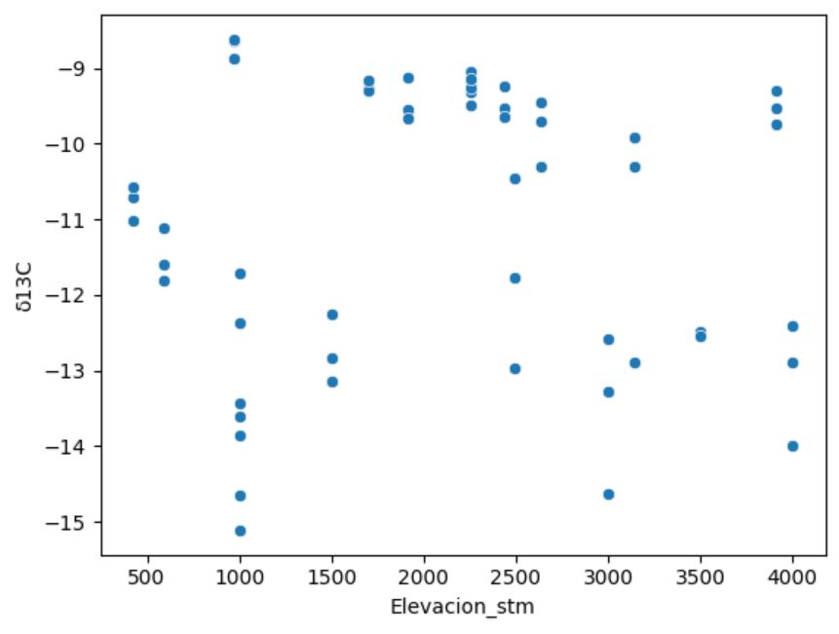

Table S2. Estimates of intrinsic water-use efficiency (iWUE), δ13C (‰ v.s.V-PDB), and Ci/Ca ratio to nitrogen (N) and phosphorus (P) addition. Results are based on linear mixed-effects models (LMMs) using a factorial N × P design. Significant effects are indicated by * (p < 0.05).

 | Elevation | Specie | N | P | N x P | Num.Obs. | R2 Marg. | AIC
iWUE | 1000 | Pouteria torta | 14.546* | 3.507 | -20.319+ | 36 |  | 306.6
 |  | Clarisia racemosa | -14.390 | 9.654 | 1.726 | 12 |  | 94.5
 | 2000 | Alchornea lojaensis | -0.703 | -6.601 | 4.128 | 45 |  | 380.1
 |  | Myrcia sp nov | 6.687 | 5.608 | -5.984 | 50 |  | 394.1
 | 3000 | Hedyosmum purpurascens | 5.492 | -5.891 | 24.202 | 21 |  | 191.9
 |  | Weinmannia loxensis | -4.356 | -8.323 | -3.588 | 18 |  | 141.5
δ13C | 1000 | Pouteria torta | 0.282 | 0.285 | -0.750 | 36 | 0.038 | 108.9
 |  | Clarisia racemosa | -1.170 | 0.788 | 0.138 | 12 | 0.352 | 35.4
 | 2000 | Alchornea lojaensis | 0.006 | -0.581 | 0.332 | 45 | 0.039 | 154.2
 |  | Myrcia sp nov | 0.551 | 0.457 | -0.486 | 50 | 0.057 | 149.5
 | 3000 | Hedyosmum purpurascens | 0.453 | -0.483 | 1.986 | 21 | 0.188 | 84.3
 |  | Weinmannia loxensis | -0.346 | -0.613 | -0.253 | 18 | 0.154 | 53.3
Ci/Ca | 1000 | Pouteria torta | -0.055* | -0.013 | 0.077+ | 36 | 0.152 | -68.5
 |  | Clarisia racemosa | 0.055 | -0.037 | -0.007 | 12 | 0.353 | -13.7
 | 2000 | Alchornea lojaensis | 0.000 | 0.027 | -0.015 | 45 | 0.039 | -97.7
 |  | Myrcia sp nov | -0.025 | -0.022 | 0.023 | 50 | 0.057 | -133.3
 | 3000 | Hedyosmum purpurascens | -0.021 | 0.022 | -0.092 | 21 | 0.188 | -20.2
 |  | Weinmannia loxensis | 0.016 | 0.029 | 0.012 | 18 | 0.155 | -32.7

Table S3. Estimates of nutrients and leaf ratios to nitrogen (N) and phosphorus (P) addition. Results are based on linear mixed-effects models (LMMs) using a factorial N × P design. Significant effects are indicated by * (p < 0.05).

Response | Elevation | Specie | N | P | N × P | Num.  Obs. | R2 Marg. | AIC
logLNC | 1000 | Pouteria torta | 0.021 | 0.082* | -0.054 | 36 | 0.132 | -54.8
 |  | Clarisia racemosa | 0.150 | 0.120 | 0.043 | 12 | 0.520 | 4.9
 | 2000 | Alchornea lojaensis | 0.125* | -0.043 | -0.044 | 45 | 0.182 | -26.6
 |  | Myrcia sp nov | 0.132** | -0.071+ | 0.041 | 49 | 0.350 | -52.1
 | 3000 | Hedyosmum purpurascens | 0.201** | 0.088 | -0.126 | 21 | 0.243 | -5.4
 |  | Weinmannia loxensis | 0.092 | 0.026 | -0.042 | 18 | 0.067 | 3.2
Narea | 1000 | Pouteria torta | 0.127 | 0.250* | -0.222 | 36 | 0.123 | 22.3
 |  | Clarisia racemosa | -0.102 | 0.159 | 0.238 | 12 | 0.342 | 12.3
 | 2000 | Alchornea lojaensis | 0.320 | -0.133 | 0.057 | 45 | 0.106 | 87.9
 |  | Myrcia sp nov | 0.401*** | -0.034 | -0.094 | 49 | 0.324 | 25.5
 | 3000 | Hedyosmum purpurascens | 0.702** | -0.022 | -0.232 | 21 | 0.433 | 33.2
 |  | Weinmannia loxensis | 0.182 | -0.000 | -0.113 | 18 | 0.114 | 16.1
logLPC | 1000 | Pouteria torta | -0.038 | 0.178+ | -0.019 | 36 | 0.153 | 7.5
 |  | Clarisia racemosa | 0.194 | 0.386** | -0.210 | 12 | 0.684 | 4.1
 | 2000 | Alchornea lojaensis | -0.019 | 0.428*** | 0.080 | 44 | 0.491 | 14.9
 |  | Myrcia sp nov | 0.027 | 1.315*** | -0.655** | 50 | 0.707 | 55.8
 | 3000 | Hedyosmum purpurascens | -0.039 | 0.492*** | -0.203 | 20 | 0.622 | 9.4
 |  | Weinmannia loxensis | 0.081 | 1.043*** | -0.869*** | 18 | 0.858 | 11.4
Parea | 1000 | Pouteria torta | -0.000 | 0.018** | -0.006 | 36 | 0.279 | -170.3
 |  | Clarisia racemosa | -0.003 | 0.033* | -0.008 | 12 | 0.437 | -27.6
 | 2000 | Alchornea lojaensis | -0.011 | 0.129*** | 0.048 | 44 | 0.485 | -69.9
 |  | Myrcia sp nov | -0.001 | 0.382*** | -0.258*** | 50 | 0.604 | -38.1
 | 3000 | Hedyosmum purpurascens | 0.008 | 0.063* | -0.034 | 20 | 0.322 | -39.6
 |  | Weinmannia loxensis | 0.009 | 0.145*** | -0.134** | 18 | 0.778 | -35.7
Leaf N:P | 1000 | Pouteria torta | 1.444 | -2.163 | -1.269 | 36 | 0.087 | 211.6
 |  | Clarisia racemosa | -0.995 | -4.953+ | 4.873 | 12 | 0.356 | 55.5
 | 2000 | Alchornea lojaensis | 2.152* | -5.550*** | -1.908 | 44 | 0.670 | 193.3
 |  | Myrcia sp nov | 0.673 | -16.578*** | 5.278* | 49 | 0.771 | 272.6
 | 3000 | Hedyosmum purpurascens | 4.611* | -5.020* | -0.826 | 20 | 0.591 | 100.9
 |  | Weinmannia loxensis | 0.234 | -11.345*** | 8.033** | 18 | 0.823 | 83.1
logLCC | 1000 | Pouteria torta | 0.005 | 0.003 | -0.008 | 33 | 0.036 | -155.4
 |  | Clarisia racemosa | 0.060 | 0.040 | -0.078 | 12 | 0.263 | -16.6
 | 2000 | Alchornea lojaensis | -0.005 | -0.006 | 0.012 | 43 | 0.029 | -183.4
 |  | Myrcia sp nov | -0.003 | -0.006 | -0.007 | 50 | 0.119 | -219.7
 | 3000 | Hedyosmum purpurascens | -0.008 | -0.003 | 0.022 | 21 | 0.104 | -71.4
 |  | Weinmannia loxensis | 0.002 | -0.006 | 0.043 | 18 | 0.215 | -45.7
Carea | 1000 | Pouteria torta | 5.475 | 2.721 | -7.198 | 33 | 0.064 | 225.4
 |  | Clarisia racemosa | -8.463* | -2.305 | 5.705 | 12 | 0.274 | 55.3
 | 2000 | Alchornea lojaensis | -5.913 | 0.059 | 12.199 | 43 | 0.045 | 355.2
 |  | Myrcia sp nov | 1.625 | 6.197 | -9.664 | 50 | 0.046 | 393.7
 | 3000 | Hedyosmum purpurascens | 5.565 | -7.692 | 2.922 | 21 | 0.194 | 148.4
 |  | Weinmannia loxensis | 1.384 | -2.826 | 1.675 | 18 | 0.072 | 108.9



Table S4. Estimates of morphological traits to nitrogen (N) and phosphorus (P) addition. Results are based on linear mixed-effects models (LMMs) using a factorial N × P design. Significant effects are indicated by * (p < 0.05).

Response | Elevation | Specie | N | P | N × P | Num.Obs. | R2 Marg. | AIC
Specific leaf area (cm2/g) | 1000 | Pouteria torta | -2.075 | -2.247 | 3.538 | 36 | 0.008 | 265.3
 |  | Clarisia racemosa | 24.498* | 7.687 | -17.815 | 12 | 0.374 | 71.2
 | 2000 | Alchornea lojaensis | 1.260 | 0.383 | -3.011 | 45 | 0.038 | 255.7
 |  | Myrcia sp nov | -0.816 | -1.871 | 2.327 | 50 | 0.045 | 263.2
 | 3000 | Hedyosmum purpurascens | -8.013 | 7.024 | -1.918 | 21 | 0.222 | 149.7
 |  | Weinmannia loxensis | -0.552 | 2.477 | 0.180 | 18 | 0.040 | 110.8
Thickness (mm) | 1000 | Pouteria torta | -0.004 | -0.001 | -0.006 | 36 | 0.029 | -128.5
 |  | Clarisia racemosa | -0.021* | 0.002 | 0.027* | 12 | 0.101 | -38.0
 | 2000 | Alchornea lojaensis | -0.023 | -0.013 | 0.029 | 45 | 0.025 | -105.8
 |  | Myrcia sp nov | -0.014 | -0.009 | 0.018 | 50 | 0.039 | -182.3
 | 3000 | Hedyosmum purpurascens | -0.003 | -0.009 | 0.016 | 21 | 0.015 | -44.1
 |  | Weinmannia loxensis | -0.019 | -0.003 | 0.007 | 18 | 0.060 | -37.8
Force to punch (kN/m) | 1000 | Pouteria torta | 0.068 | 0.030 | -0.029 | 36 | 0.048 | -17.0
 |  | Clarisia racemosa | -0.124 | -0.007 | 0.161 | 12 | 0.077 | 6.8
 | 2000 | Alchornea lojaensis | -0.082 | -0.117* | 0.087 | 45 | 0.100 | -21.5
 |  | Myrcia sp nov | -0.025 | -0.024 | 0.048 | 50 | 0.011 | -68.2
 | 3000 | Hedyosmum purpurascens | 0.047 | -0.159+ | 0.163 | 21 | 0.255 | 3.9
 |  | Weinmannia loxensis | 0.002 | 0.050 | 0.010 | 18 | 0.093 | -11.8
Leaf area (cm2) | 1000 | Pouteria torta | -1.191 | 0.012 | -4.081 | 36 | 0.010 | 301.9
 |  | Clarisia racemosa | 5.461 | -1.581 | -8.123 | 12 | 0.121 | 69.3
 | 2000 | Alchornea lojaensis | -4.324 | 3.376 | -4.023 | 45 | 0.146 | 312.6
 |  | Myrcia sp nov | -0.613 | -3.043 | 2.123 | 50 | 0.053 | 300.0
 | 3000 | Hedyosmum purpurascens | -3.253 | 3.459 | -2.646 | 21 | 0.290 | 117.1
 |  | Weinmannia loxensis | 0.289 | 0.288 | -0.134 | 18 | 0.146 | 29.2
dry matter content (mg/g) | 1000 | Pouteria torta | 1.561 | -17.703 | 9.484 | 36 | 0.041 | 341.0
 |  | Clarisia racemosa | -17.635 | -9.836 | -14.250 | 12 | 0.371 | 88.9
 | 2000 | Alchornea lojaensis | 8.004 | -2.495 | 5.534 | 45 | 0.034 | 407.5
 |  | Myrcia sp nov | 7.807 | 0.491 | -14.915 | 50 | 0.036 | 450.6
 | 3000 | Hedyosmum purpurascens | 26.973 | -28.263+ | -11.837 | 21 | 0.428 | 177.6
 |  | Weinmannia loxensis | 26.546 | -8.164 | -29.509 | 18 | 0.124 | 161.1

Figure S2. Boxplots of (a) intrinsic water-use efficiency (iWUE), (b) leaf nitrogen content (LNC), (c) leaf phosphorus content (LPC), and (d) leaf N:P ratio from the control plots. Boxes represent the interquartile range, the central line indicates the median, and points represent individual observations. Different letters indicate significant differences among species based on one-way ANOVA followed by Tukey's HSD post hoc test (P < 0.05).
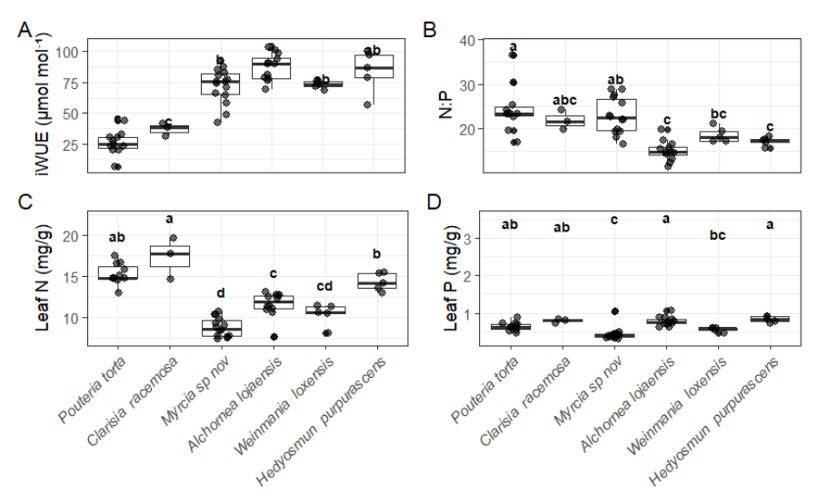
Figure S2. Relationships between intrinsic water-use efficiency (iWUE) and leaf functional traits across six tropical montane tree species. Panels show standardized major axis (SMA) regressions between iWUE and (a) nitrogen per unit area (Narea) or (b) specific leaf area (SLA). Points represent individual observations and are coloured according to nutrient treatment. Solid lines indicate species-specific SMA fits, and equations and coefficients of determination (R²) are shown within each panel. Exploratory SMA analyses revealed a consistent positive association between Narea and iWUE across species, whereas SLA was negatively associated with iWUE in all species. These relationships represent trait covariation among individuals and should be interpreted as exploratory, as SMA analyses did not account for the experimental treatment structure.
A
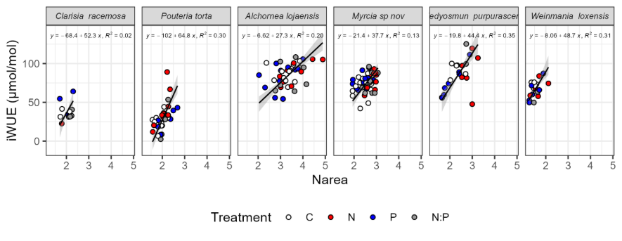
B
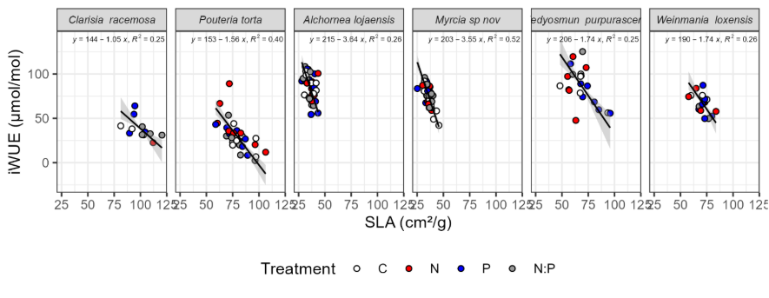
C
